**Spotify Account & APP registration**

**Added 27.07.2018.**

1. Go to <https://www.spotify.com/>

and press button “Sign up”.

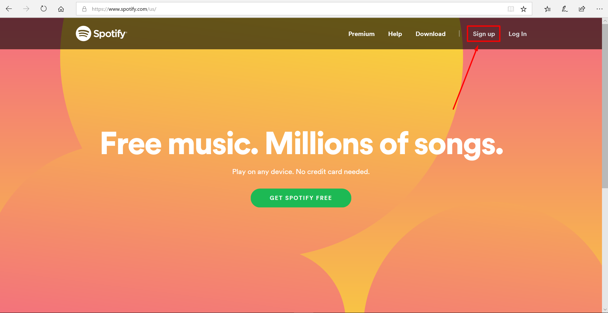

2. Fill the fields or sign up with Facebook account

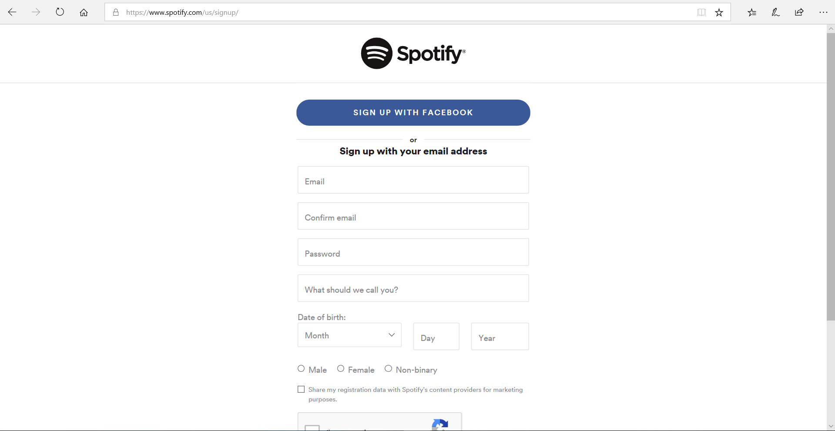

3. Then press “Sign up” button.

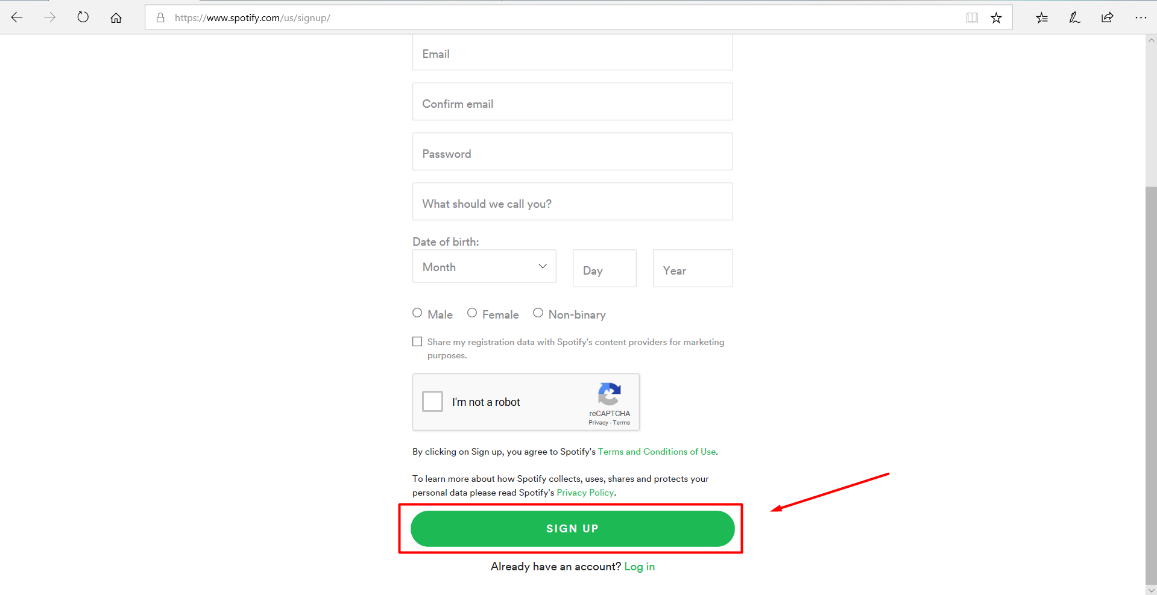

4. After registration go to <https://developer.spotify.com/>

and click on “DASHBOARD”.

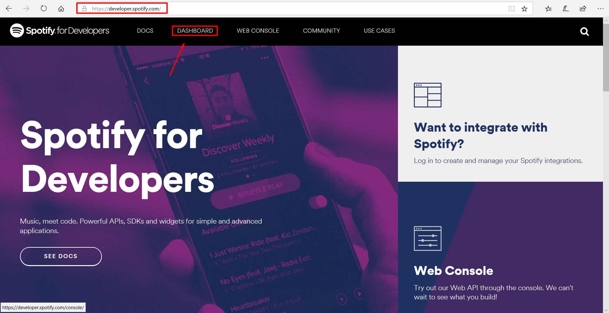

5.Press button “Log in”.

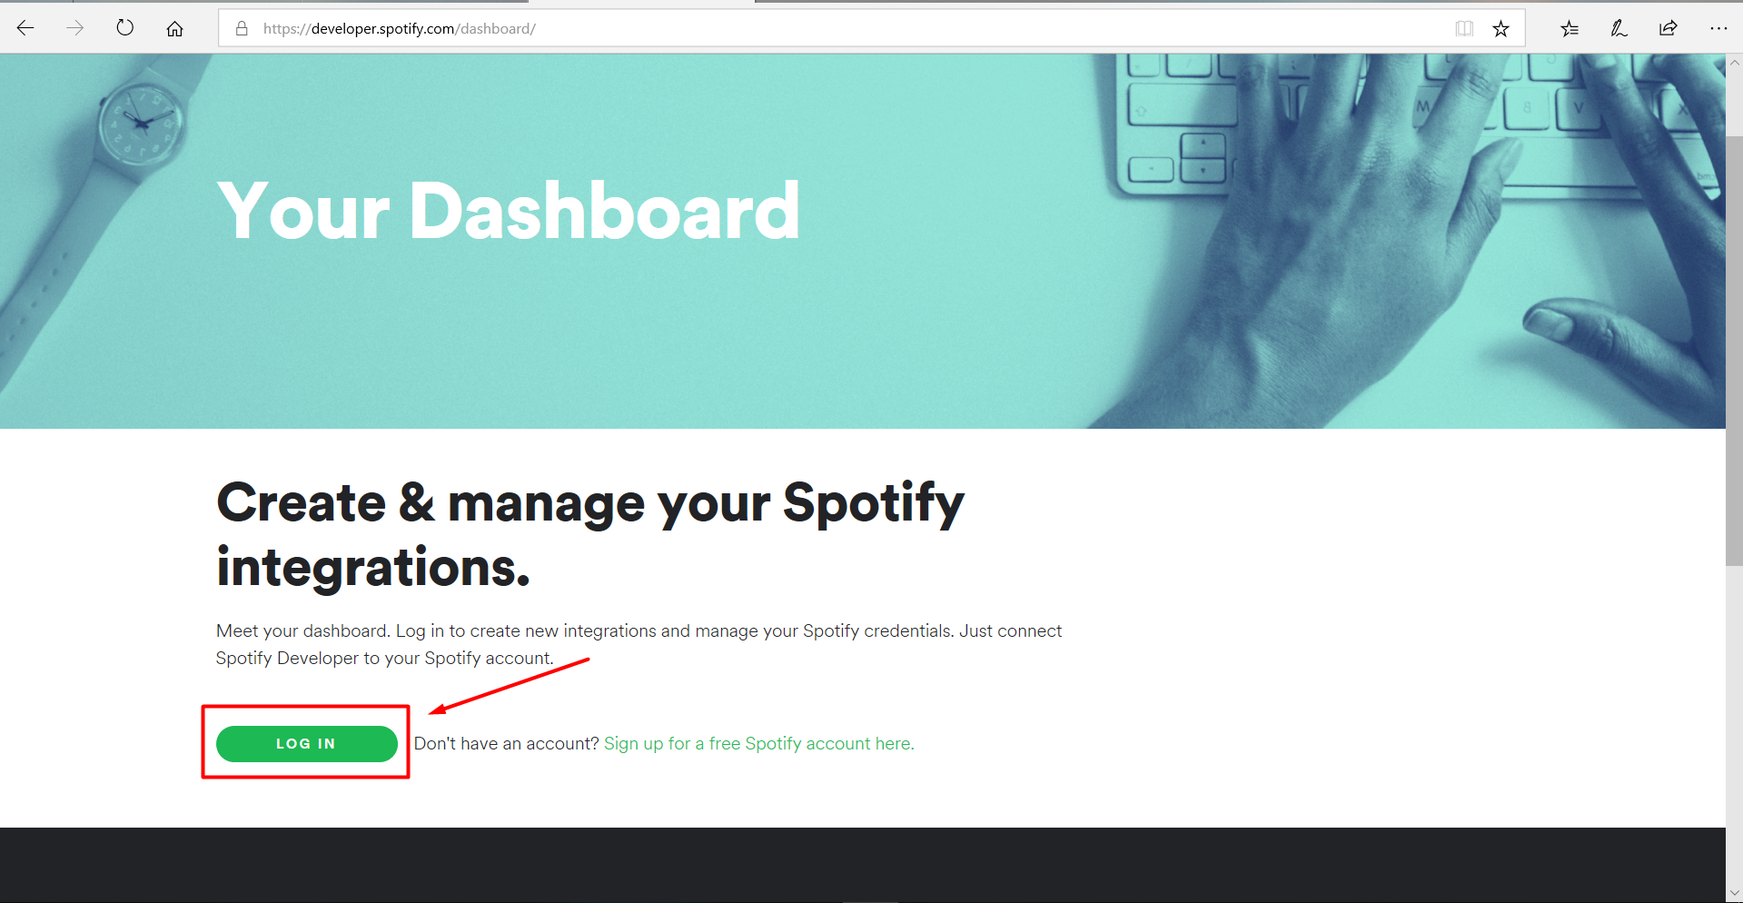

6. Read Spotify Developer Terms of Service and if you agree then press “Accept” button

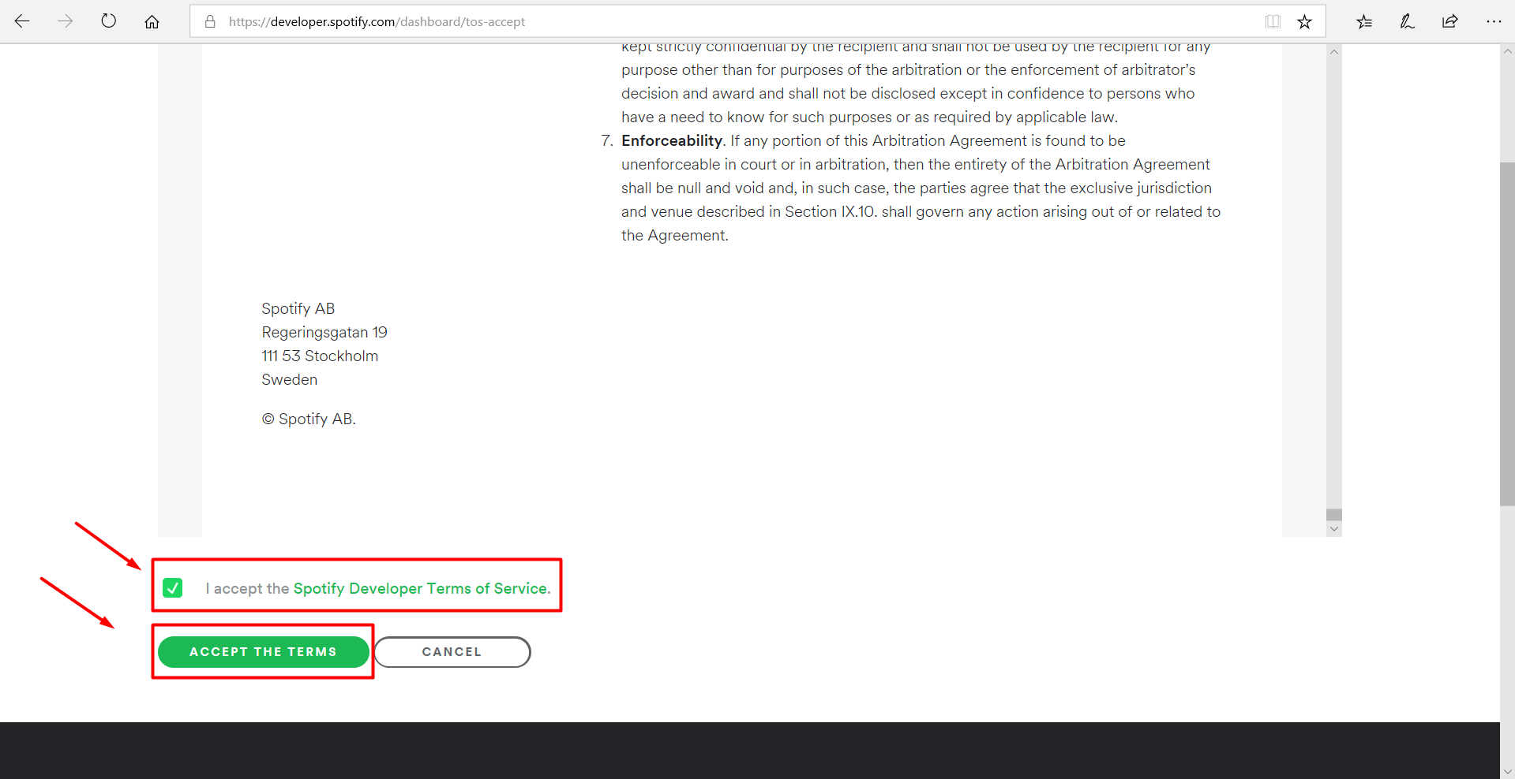

7. Click on the “CREATE AN APP”.

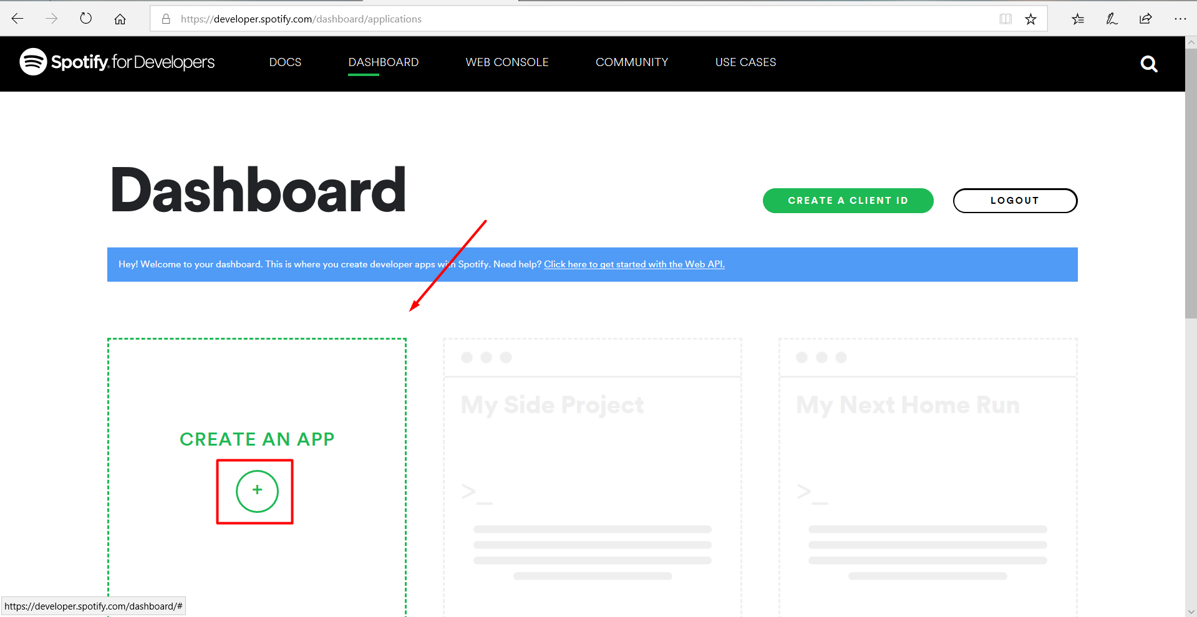

8.Fill the fields.

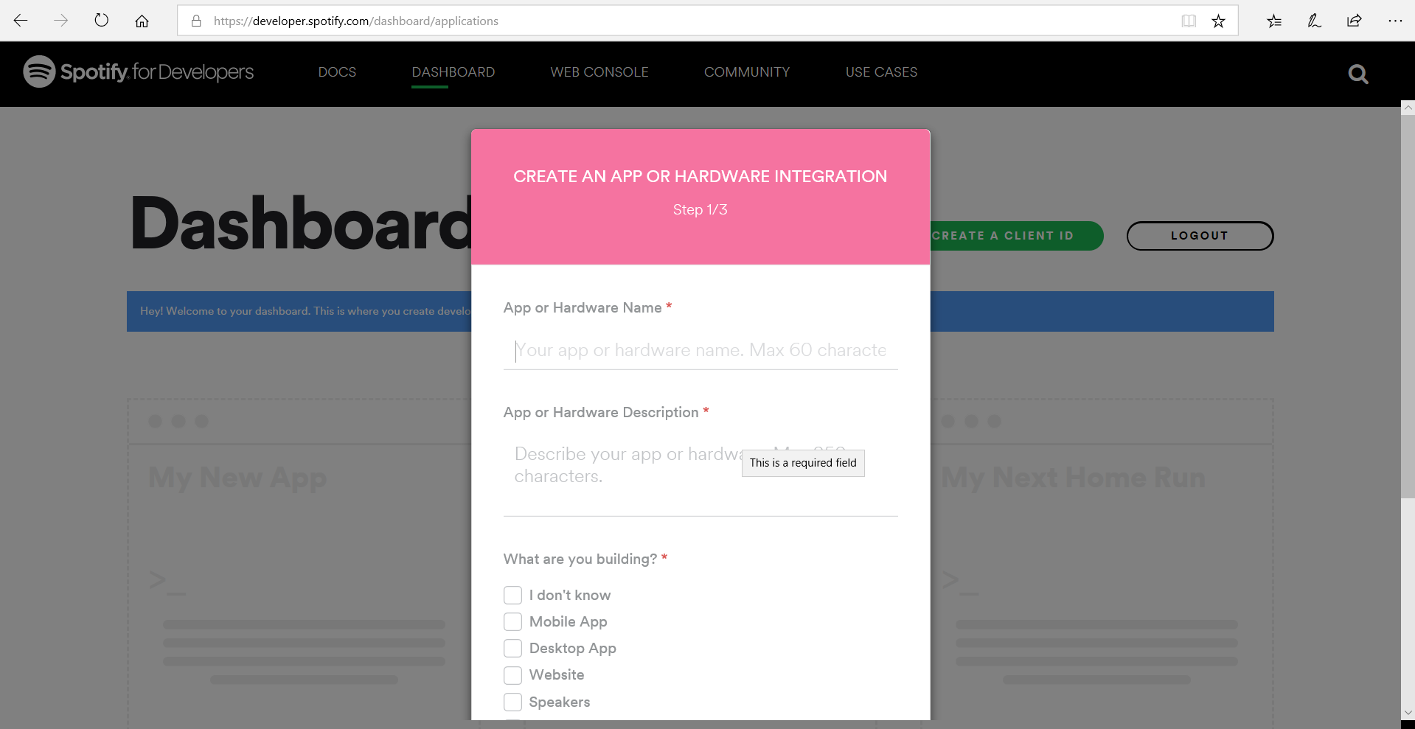

9. Press a “Next” button.

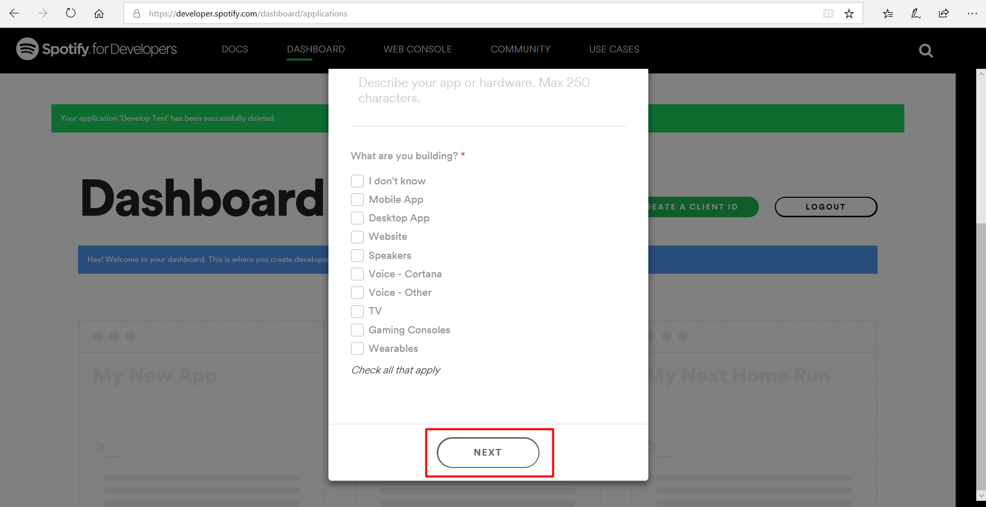

10. If developing for commercial integration press “Yes”,

if non-commercial press “NO” button.

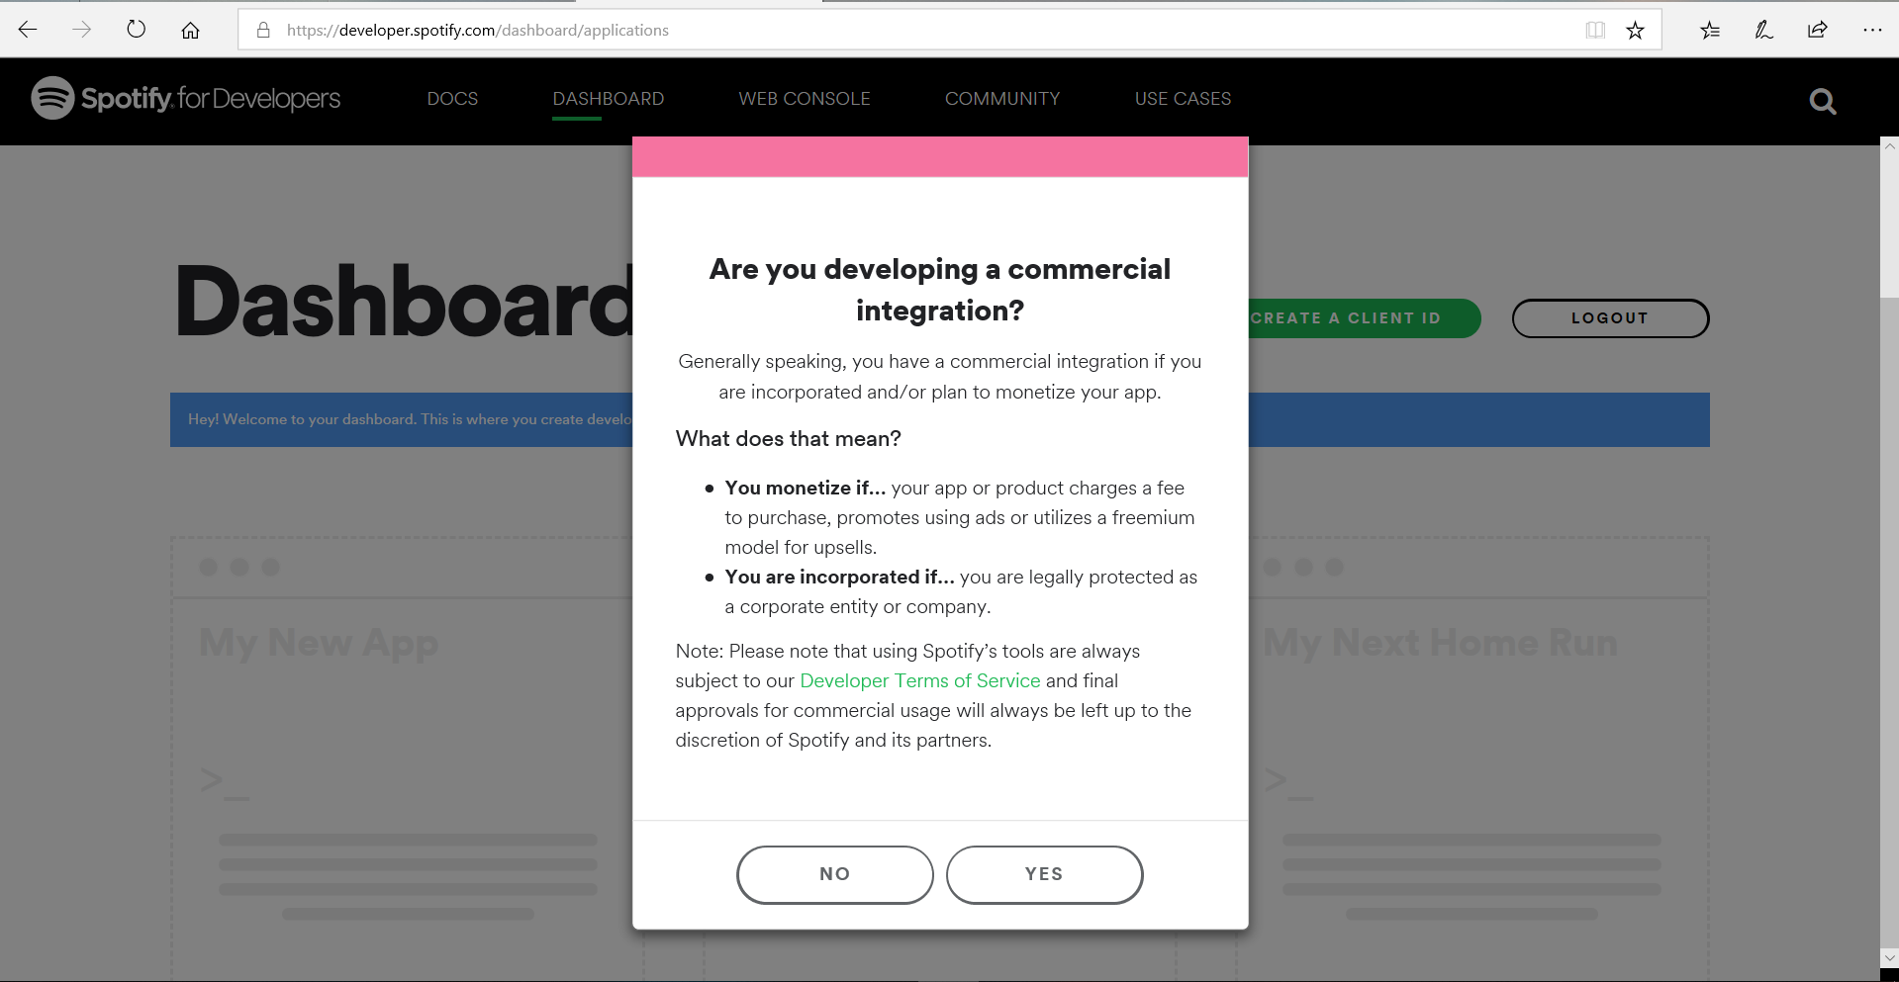

11. Press a “SUBMIT” button for create Non-commercial app.

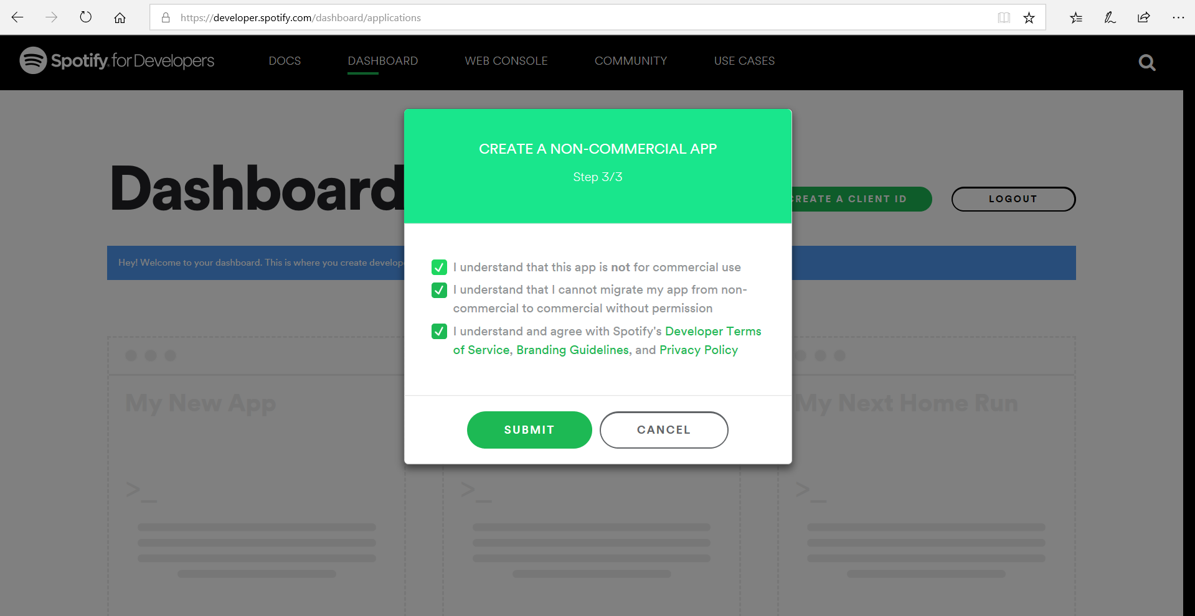

12. After creating app you will be referenced to app page.

Press an “EDIT SETTINGS” button.

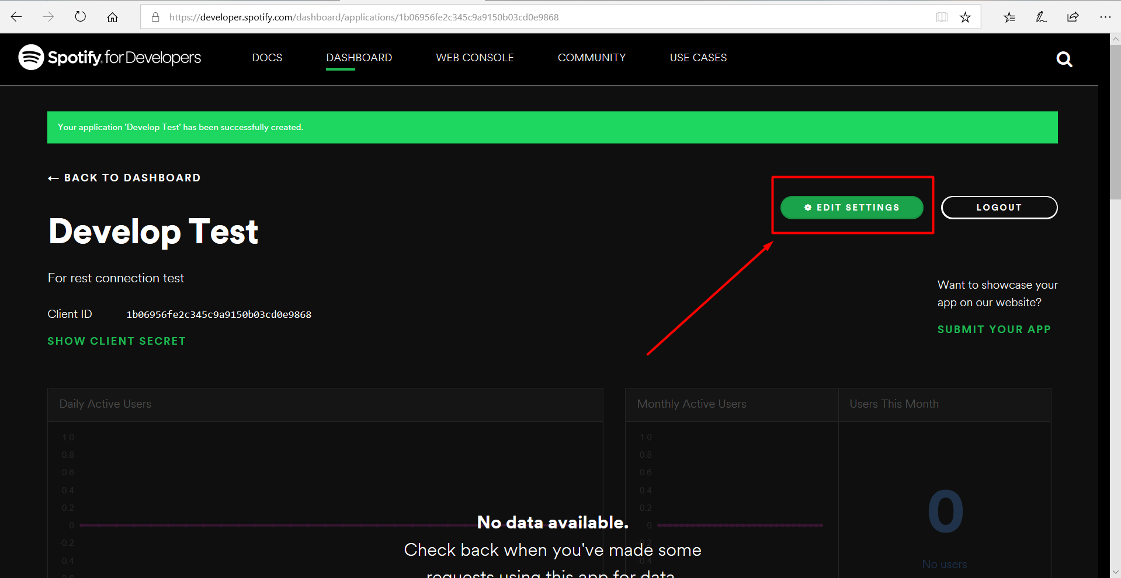

13. Add redirect url  
(For example: <http://localhost/api/authprovider/signin>).

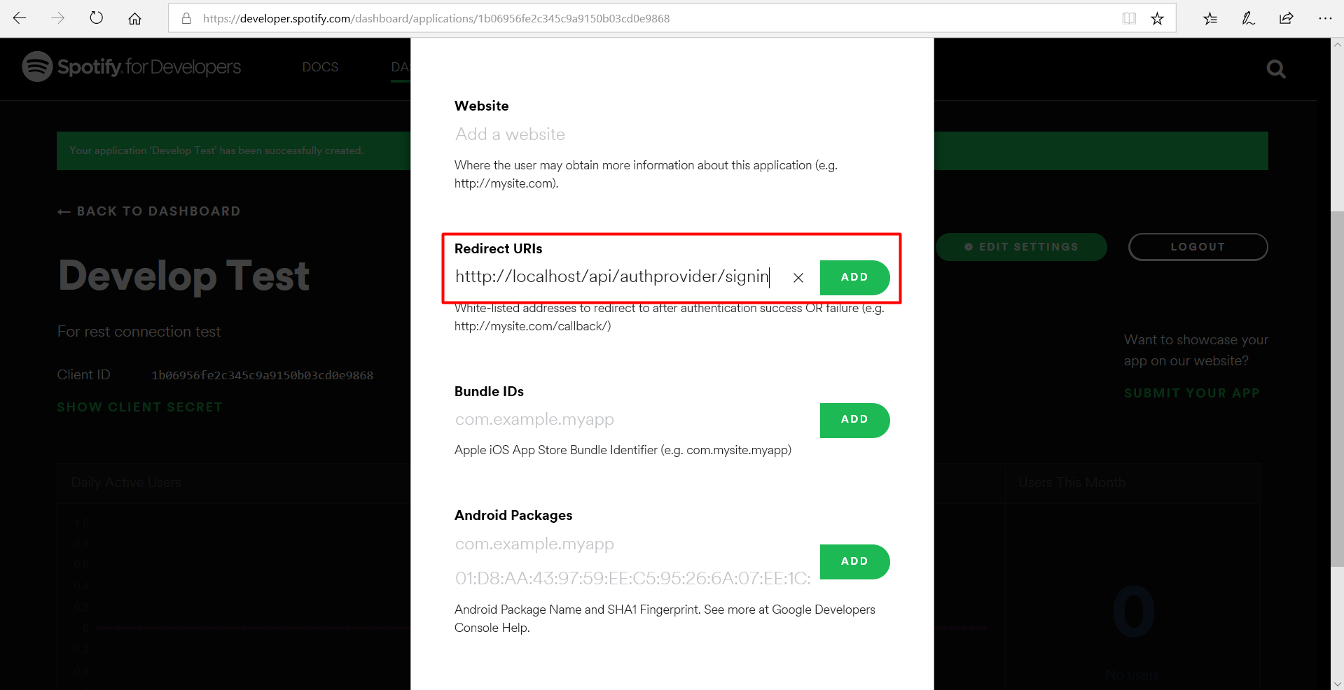

14.Press a “SAVE” button.

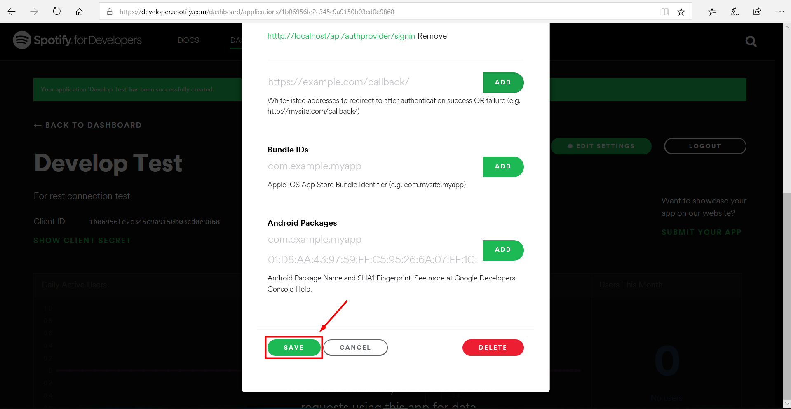

15. Copy Client ID and Client Secret to your app.

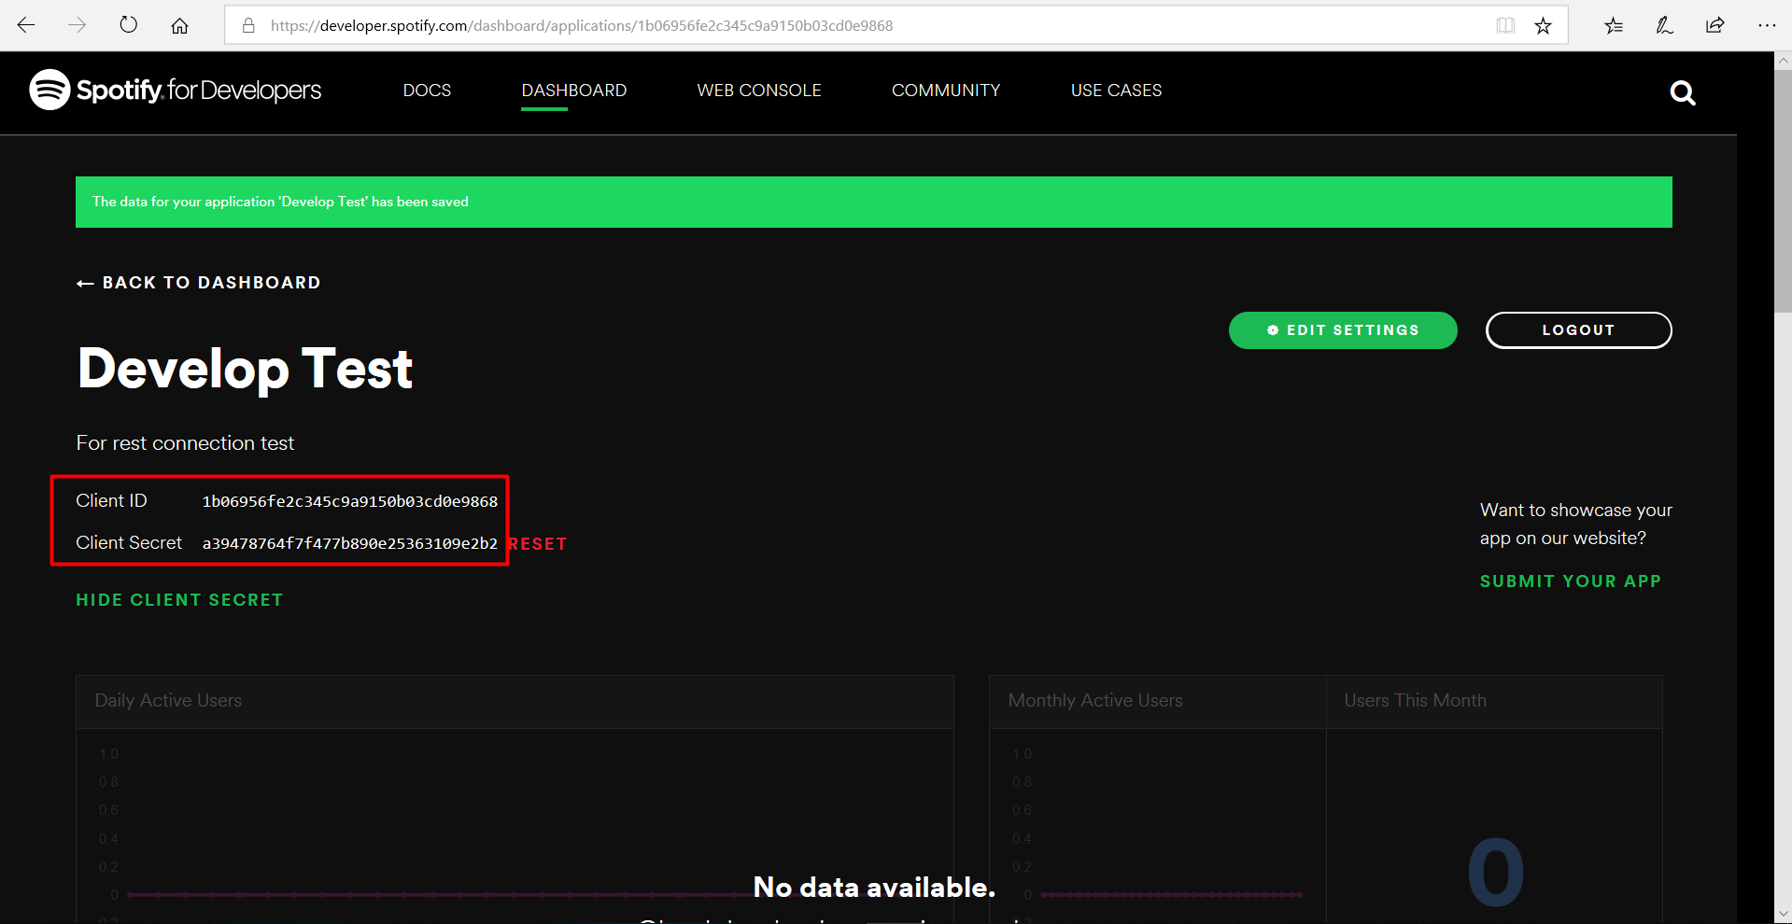

Good Luck!